**Comp-122 Assignment 2**

**Andrew Lawler**

Introduction

For this assignment I was tasked with creating a cipher text encryption and decryption program.

For the first part of the task I was required to create an interface and then implement the interface in part B.

For part b, I had to implement the methods in a class called Caesar. Within this class I had the methods (rotate, frequencies, chiSquared and decipher). I implemented these methods using my knowledge of cipher text and the suitable examples shown to us.

Note: I asked Patrick if I could use a code snippet and he said it was fine. I used this snippet, which I heavily edited, to handle the rotating of lowercase and uppercase letters. I showed in the code which if statement this was. All code around it (eg: is letter) and other parts, are all my own. I also edited the code snippet as I wanted the code to be easy to edit for other inputted languages. You can see with the link provided in the code that the code itself has been changed a lot.

Next Parts

**c.** Testing input for Rotate.java

I implemented a system that will print wrong input length when there is not two inputs. It then tests the inputs to make sure they are in the correct format.

|  |  |  |  |
| --- | --- | --- | --- |
| Input | Expected Output | Actual Output | Comments |
|  | Too few parameters!  Usage: java Rotate n ‘cipher text’ | Too few parameters!  Usage: java Rotate n ‘cipher text’ | This shows that the program ends with an error message when there is nothing entered. |
| . | Too few parameters!  Usage: java Rotate n ‘cipher text’ | Too few parameters!  Usage: java Rotate n ‘cipher text’ | This result tells us that the program will revoke all types of input when there is not the correct amount of inputs. |
| 3 | Too few parameters!  Usage: java Rotate n ‘cipher text’ | Too few parameters!  Usage: java Rotate n ‘cipher text’ | This example shows the error message once again. |
| Andy | Too few parameters!  Usage: java Rotate n ‘cipher text’ | Too few parameters!  Usage: java Rotate n ‘cipher text’ | This shows that the program handles the one string input and provides the same error message. |
| Andy 3 | No integer first, no string second, wrong input | You did not enter an integer first!  You did not enter a string second!  Wrong inputs! | The output here shows that order matters. It tested the first input and found it was not an integer and also found the second input was not a string. These are the wrong inputs. |
| 3 Andy | dqgb | dqgb | Here you can see if we enter in the correct format it will work. |

**d.** Testing input for BreakCaesar.java

I implemented the same system as for part c but with one input this time. It will check if the input size is equal to one and will then check if that input is a string. If either case is false we will get a specific error message.

|  |  |  |  |
| --- | --- | --- | --- |
| Input | Expected Output | Actual Output | Comments |
|  | Too few parameters!  Usage: java BreakCaesar ‘cipher text’ | Too few parameters!  Usage: java BreakCaesar ‘cipher text’ | This shows that the program requires inputs and will not let you enter nothing. |
| 3 | You didn’t enter a string | You did not enter a string! | This shows that you need to enter a string because the input is tested. |
| . | . | . | This was to test that the function did in fact let this in. A dot is allowed as we may form sentences to decrypt. |
| xf bsf ifsf | we are here | we are here | This was to test that the program would work. |

**e.** UML Diagram

Class Description

I first initialized the interface for the assignment. This interface is called RotationCipher and its job is to simply state the methods for the subclass to implement. Interfaces state methods as public but it is known that they are in fact abstract also. Once I had implemented my interface, I moved onto my Caesar subclass. This subclass implements the interface itself. I wrote the code for the methods and made sure they followed the same input parameters and same name as the ones in the interface, it in turn overrides them.

I then was tasked with implementing the BreakCaesar and Rotate applications. For this task I extended the Caesar class further, once in the subclass I created a constructor which takes the string input and sends it to the decipher method from the parent class. This is the way my application works. I followed the same layout for Rotate. I extended the subclass and created a constructor which took the inputted argument and send it to the rotate method which in turn gets printed out.

I think the way I designed my classes is good because they all link together well and it keeps the code neat and efficient.

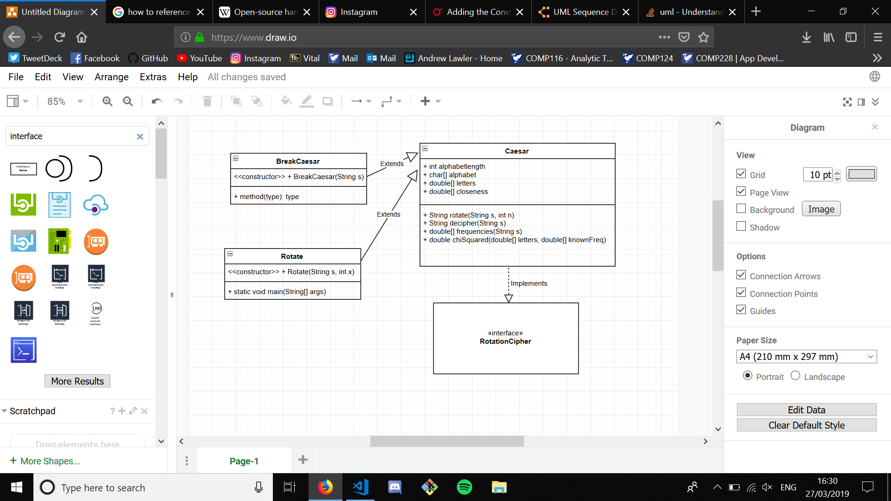UML Diagram

**f.** JavaDocs

**g.**

**Question: Caesar would have written in Latin instead of English. What would we do differently if we know the language we’re examining isn’t English but some other language?**

This scenario would be quite easy to implement. First, I would need to edit the global variables I provided at the top of the Caesar program. I coded the entire assignment to suit this scenario. You would simply change the alphabetlength integer to the length of your new languages alphabet and then also type the alphabet as a string into the alphabet char array part below. This would then implement these changes throughout the entire program as the entire program runs off of the values implemented in these variables. You would then only need to make one more change. You would edit the knownFreq double array with the frequencies for every letter in your language. Once complete, the code would run perfectly for your new given language.

**h.**

**Question: Suppose we (somehow) know that the person doing the encryption uses one shift value for lower case letters, and a different shift value for upper case letters. What would we have to do differently? How would that affect our calculations, or how would we have to alter our program/calculations to account for this?**